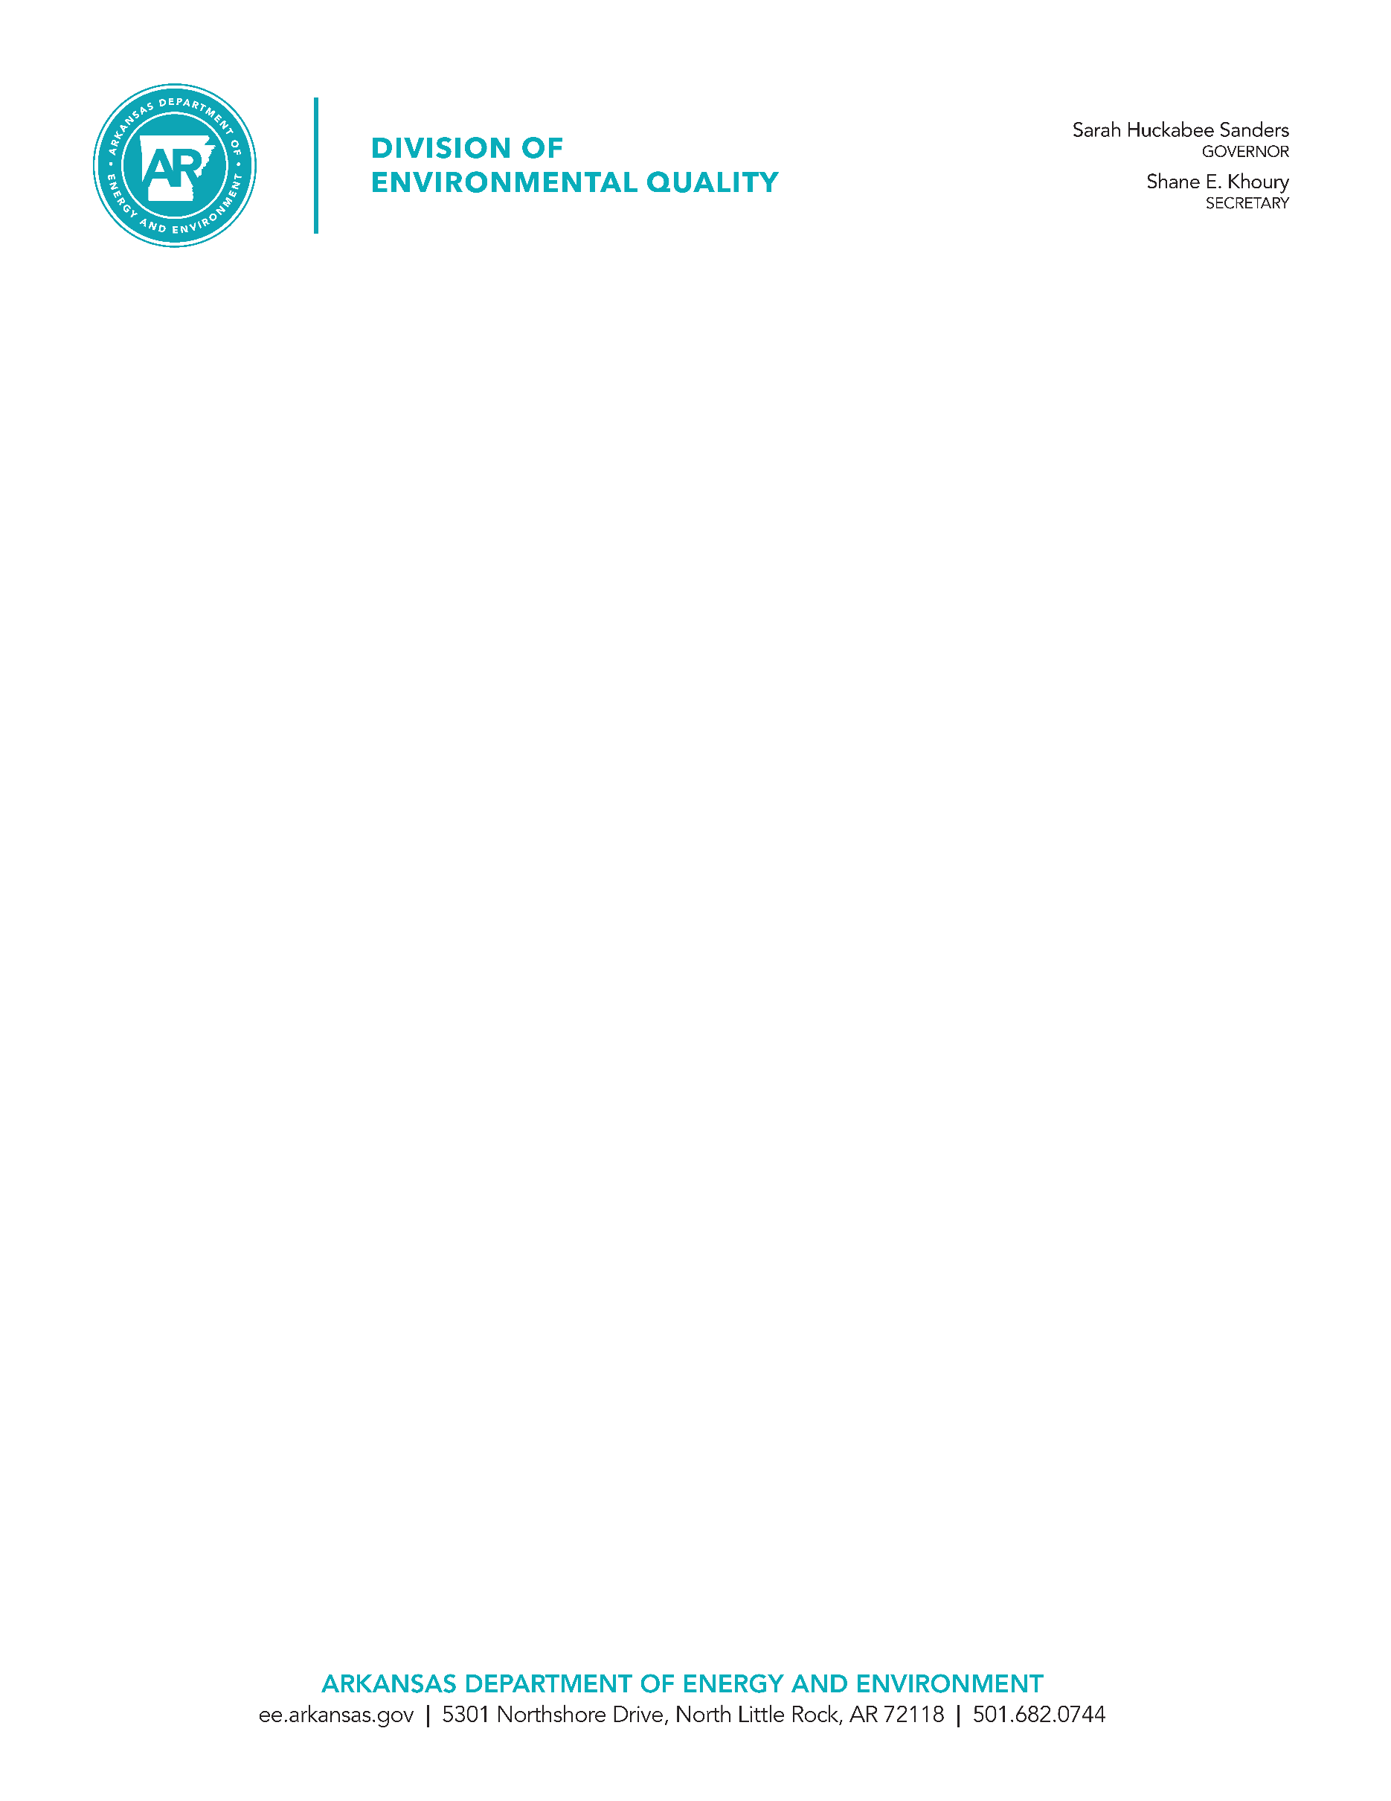

**Application Form PPS**

**Priority Pollutant Scan Information**

**For Industrial Facilities Only**

**ATTENTION**

**“Clean” Sampling Techniques**

Water quality (WQ) standards (Based on aquatic toxicity and human health criteria) for many of the heavy metals are “at” analytical methods detection levels (MDL).

It is recognized that **unclean** sampling and lab techniques can and do **cause** contamination sometimes causing measurements to be “seen” as **violations** of the WQ standards. Therefore, the permittee must recognize the **importance** of **eliminating** contamination.

For personnel responsible for collecting samples in answer to effluent monitoring requirements, the Division recommends following sample collection and handling in accordance with EPA’s **Method 1669: Sampling Ambient Water for Determination of Trace Metals at EPA Water Quality Criteria Levels** as closely as possible and as economically feasible. A copy of Method 1669 is available online at:

<https://www.epa.gov/sites/default/files/2015-10/documents/method_1669_1996.pdf>

Please convey to your contract testing laboratory the extreme importance of proper sampling techniques associated with analytical testing for heavy metals. Some of the techniques may be considered too expensive to justify implementation but it could be in the best interest of your facility to **submit the PPS Form by using common sense “Clean” Sampling Techniques.**

**GENERAL INSTRUCTIONS**

1. **Generation of a form similar to the PPS form is prohibited without express written permission of DEQ, Discharge Permits Section, Office of Water Quality.**
2. All major facilities, all categorical industries, or any facility that believes there are priority pollutant(s) present in their discharge, must submit the Form PPS.
3. All facilities must monitor for **metals,** **cyanide,** and **total phenolic compounds**.
4. Testing requirements for categorical industries are listed in Attachment 1. Industries are required to report a minimum of one sample for each of the pollutants monitored. Additional laboratory analysis table sheets must be attached to this form if more than one sample is collected for any parameter, unless the additional samples have already been reported to DEQ on other forms such as DMRs.
5. A facility is only required to monitor for 2,3,7,8-Tetrachloro-dibenzo-p-dioxin (TCDD) if it uses or manufactures any of the 2,3,7,8-TCDD congeners listed in 40 C.F.R. § 122.21(g)(7)(viii)(A); OR if the applicant knows or has reason to believe that TCDD is or may be present in an effluent.
6. Testing requirements for Hexavalent Chromium (Chromium 6+, dissolved) may be waived if Total Recoverable Chromium is not detected in the effluent.
7. The threshold level (i.e., Method Detection Limit (MDL), Minimum Quantification Level (MQL), Minimum Level (ML), Reporting Limit (RL), or other designated method endpoints) **must be as low as Minimum Quantification Levels** (**MQL**) listed in the tables. MQLs are based on EPA Methods, EPA Region 6 guidance dated April 10, 2006, and EPA Region 6 guidance dated February 8, 2008. Where no other information is available, MQL is assumed to be equal to 3.3 × MDL.
8. All the units must be expressed in μg/l (Micrograms per liter).
9. **All the results less than Method Detection Level Achieved may be reported as ND (Not Detected).**
10. The data requested for the priority pollutant scan in the enclosures shall be submitted with copies of the laboratory results, chain of custody sheets, and threshold level (i.e. MDL, MQL, ML, RL, etc.). Certification that QA/QC procedures were implemented must be submitted with the requested information.
11. All analyses must be performed at the minimum level of sensitivity. The analyses must demonstrate that an acceptable calibration point as low as MQL was used. Test procedures must conform to approved EPA methodology listed in 40 C.F.R. Part 136. For Chlorpyrifos, EPA Method 608.3 may be used in addition to the approved methods listed in 40 C.F.R. Part 136.

**ATTACHMENT 1**

**TESTING REQUIREMENTS FOR ORGANIC TOXIC POLLUTANTS INDUSTRY CATEGOR**Y

Each industry category marked with an “X” under an organic toxic pollutant category must report effluent sample data for the pollutants listed under those categories on the tables of this form.

|  |  |  |  |  |
| --- | --- | --- | --- | --- |
| **Industry Category** | **Organic Toxic Pollutant Category** | | | |
| **Volatile** | **Acid** | **Base/Neutral** | **Pesticide/PCB** |
| Adhesives & Sealants | X | X | X | - |
| Aluminum Forming | X | X | X | - |
| Auto & Other Laundries | X | X | X | X |
| Battery Manufacturing | X | - | X | - |
| Coal Mining | X | X | X | X |
| Coil Coating | X | X | X | - |
| Copper Forming | X | X | X | - |
| Electric & Electronic Compounds | X | X | X | X |
| Electroplating | X | X | X | - |
| Explosives Manufacturing | - | X | X | - |
| Foundries | X | X | X | - |
| Gum & Wood Chemicals | X | X | X | X |
| Inorganic Chemicals Manufacturing | X | X | X | - |
| Iron & Steel Manufacturing | X | X | X | - |
| Leather Tanning & Finishing | X | X | X | X |
| Mechanical Products Manufacturing | X | X | X | - |
| Nonferrous Metals Manufacturing | X | X | X | X |
| Ore Mining | X | X | X | X |
| Organic Chemicals Manufacturing | X | X | X | X |
| Paint & Ink Formulation | X | X | X | X |
| Pesticides | X | X | X | X |
| Petroleum Refining | X | X | X | X |
| Pharmaceutical Preparations | X | X | X | - |
| Photographic Equipment & Supplies | X | X | X | X |
| Plastic & Synthetic Materials Manufacturing | X | X | X | X |
| Plastic Processing | X | - | - | - |
| Porcelain Enameling | X | - | X | X |
| Printing & Publishing | X | X | X | X |
| Pulp & Paperboard Mills | X | X | X | X |
| Rubber Processing | X | X | X | - |
| Soap & Detergent Manufacturing | X | X | X | - |
| Steam Electric Power Plants | X | X | X | - |
| Textile Mills | X | X | X | X |
| Timber Products Processing | X | X | X | X |

**ARKANSAS DIVISION OF ENVIRONMENTAL QUALITY**

**PPS REQUIREMENTS**

Name of facility:

____________________________________________________________________________________

Name, address and telephone number of laboratory:

____________________________________________________________________________________

____________________________________________________________________________________

Is the lab certified by the State of Arkansas? Yes ____ No ___

What are the certification dates?

Issued date _____________________ Expiration date ____________________

Is the laboratory certified for all the parameters?

Yes ____ No ____ (Explain)

_____________________________________________________________________________________

_____________________________________________________________________________________

Sample location (Outfall No.):

______________________________________________________________________

Samples collected by:

Name _________________________________________________________________

Title __________________________________________________________________

Telephone _____________________________________________________________

I certify under penalty of law that this document and all attachments were prepared under my direction of supervision in accordance with a system designed to assure that qualified personnel properly gather and evaluate the information submitted. Based on my inquiry of the person or persons who manage the system, or those persons directly responsible for gathering the information submitted is, to the best of my knowledge and belief, accurate, and complete. I am aware that there are significant penalties for submitting false information, including the possibility of fine and imprisonment for knowing violations.

____________________________________________________________________________________

Printed Name of Responsible Official Title

____________________________________________________________________________________

Responsible Official Signature Date signed

|  |  |  |  |  |
| --- | --- | --- | --- | --- |
| **Metals, Cyanide, and  Total Phenolic Compounds** | **Laboratory Analysis** | | | **Maximum Allowable MQL (μg/l)** |
| **Results**  **(μg/l)** | **Approved EPA Method used** | **Detection Level Achieved (μg/l)** |
| Antimony, Total Recoverable |  |  |  | 60 |
| Arsenic, Total Recoverable |  |  |  | 0.5 |
| Beryllium, Total Recoverable |  |  |  | 0.5 |
| Cadmium, Total Recoverable |  |  |  | 0.5 |
| Chromium, Total Recoverable |  |  |  | 10 |
| Chromium (6+), Dissolved |  |  |  | 10 |
| Copper, Total Recoverable |  |  |  | 0.5 |
| Lead, Total Recoverable |  |  |  | 0.5 |
| Mercury, Total Recoverable |  |  |  | 0.005 |
| Nickel, Total Recoverable |  |  |  | 0.5 |
| Selenium, Total Recoverable |  |  |  | 5 |
| Silver, Total Recoverable |  |  |  | 0.5 |
| Thallium, Total Recoverable |  |  |  | 0.5 |
| Zinc, Total Recoverable |  |  |  | 20 |
| Cyanide, Total Recoverable |  |  |  | 10 |
| Phenols, Total Recoverable  (Total Phenolic Compounds) |  |  |  | 5 |

|  |  |  |  |  |
| --- | --- | --- | --- | --- |
| **Volatile Organic Compounds** | **Laboratory Analysis** | | | **Maximum Allowable MQL**  **(μg/l)** |
| **Results**  **(μg/l)** | **Approved EPA Method used** | **Detection Level Achieved (μg/l)** |
| Acrolein |  |  |  | 50 |
| Acrylonitrile |  |  |  | 20 |
| Benzene |  |  |  | 10 |
| Bromoform |  |  |  | 10 |
| Carbon Tetrachloride |  |  |  | 2 |
| Chlorobenzene |  |  |  | 10 |
| Chlorodibromomethane |  |  |  | 10 |
| Chloroethane |  |  |  | 50 |
| 2-Chloroethyl vinyl ether |  |  |  | 10 |
| Chloroform |  |  |  | 10 |
| Dichlorobromomethane |  |  |  | 10 |
| 1,1-Dichloroethane |  |  |  | 10 |
| 1,2-Dichloroethane |  |  |  | 10 |
| 1,1-Dichloroethylene |  |  |  | 10 |
| 1,2-Dichloropropane |  |  |  | 10 |
| 1,3-Dichloropropylene |  |  |  | 10 |
| Ethylbenzene |  |  |  | 10 |
| Methyl Bromide [Bromomethane] |  |  |  | 50 |
| Methyl Chloride [Chloromethane] |  |  |  | 50 |
| Methylene Chloride |  |  |  | 20 |
| 1,1,2,2-Tetrachloroethane |  |  |  | 10 |
| Tetrachloroethylene |  |  |  | 10 |
| Toluene |  |  |  | 10 |
| 1,2-trans-Dichloroethylene |  |  |  | 10 |
| 1,1,1-Trichloroethane |  |  |  | 10 |
| 1,1,2-Trichloroethane |  |  |  | 10 |
| Trichloroethylene |  |  |  | 10 |
| Vinyl Chloride |  |  |  | 10 |

|  |  |  |  |  |
| --- | --- | --- | --- | --- |
| **Acid-Extractable Compounds** | **Laboratory Analysis** | | | **Maximum Allowable MQL (μg/l)** |
| **Results**  **(μg/l)** | **Approved EPA Method used** | **Detection Level Achieved (μg/l)** |
| 2-Chlorophenol |  |  |  | 10 |
| 2,4-Dichlorophenol |  |  |  | 10 |
| 2,4-Dimethylphenol |  |  |  | 10 |
| 4,6-Dinitro-o-Cresol |  |  |  | 50 |
| 2,4-Dinitrophenol |  |  |  | 50 |
| 2-Nitrophenol |  |  |  | 20 |
| 4-Nitrophenol |  |  |  | 50 |
| P-Chloro-m-Cresol |  |  |  | 10 |
| Pentachlorophenol |  |  |  | 5 |
| Phenol |  |  |  | 10 |
| 2,4,6-Trichlorophenol |  |  |  | 10 |

|  |  |  |  |  |
| --- | --- | --- | --- | --- |
| **Base/Neutral Compounds** | **Laboratory Analysis** | | | **Maximum Allowable MQL (μg/l)** |
| **Results**  **(μg/l)** | **Approved EPA Method used** | **Detection Level Achieved (μg/l)** |
| Acenaphthene |  |  |  | 10 |
| Acenaphthylene |  |  |  | 10 |
| Anthracene |  |  |  | 10 |
| Benzidine |  |  |  | 50 |
| Benzo(a)anthracene |  |  |  | 5 |
| Benzo(a)pyrene |  |  |  | 5 |
| 3,4-Benzofluoranthene |  |  |  | 10 |
| Benzo(ghi)perylene |  |  |  | 20 |
| Benzo(k)fluoranthene |  |  |  | 5 |
| Bis(2-chloroethoxy) methane |  |  |  | 10 |
| Bis(2-chloroethyl) ether |  |  |  | 10 |
| Bis(2-chloroisopropyl) ether |  |  |  | 10 |
| Bis(2-ethylhexyl) phthalate |  |  |  | 10 |
| 4-Bromophenyl phenyl ether |  |  |  | 10 |
| Butyl benzyl phthalate |  |  |  | 10 |
| 2-Chloronaphthalene |  |  |  | 10 |
| 4-Chlorophenyl phenyl ether |  |  |  | 10 |
| Chrysene |  |  |  | 5 |
| Dibenzo (a, h) anthracene |  |  |  | 5 |
| 1,2-Dichlorobenzene |  |  |  | 10 |
| 1,3-Dichlorobenzene |  |  |  | 10 |
| 1,4-Dichlorobenzene |  |  |  | 10 |
| 3,3'-Dichlorobenzidine |  |  |  | 5 |
| Diethyl Phthalate |  |  |  | 10 |
| Dimethyl Phthalate |  |  |  | 10 |
| Di-n-Butyl Phthalate |  |  |  | 10 |
| 2,4-Dinitrotoluene |  |  |  | 10 |
| 2,6-Dinitrotoluene |  |  |  | 10 |
| Di-n-octyl Phthalate |  |  |  | 10 |

|  |  |  |  |  |
| --- | --- | --- | --- | --- |
| **Base/Neutral Compounds** | **Laboratory Analysis** | | | **Maximum Allowable MQL (μg/l)** |
| **Results**  **(μg/l)** | **Approved EPA Method used** | **Detection Level Achieved (μg/l)** |
| 1,2-Diphenylhydrazine |  |  |  | 20 |
| Fluoranthene |  |  |  | 6.6 |
| Fluorene |  |  |  | 10 |
| Hexachlorobenzene |  |  |  | 5 |
| Hexachlorobutadiene |  |  |  | 10 |
| Hexachlorocyclo-pentadiene |  |  |  | 10 |
| Hexachloroethane |  |  |  | 20 |
| Indeno (1,2,3-cd) pyrene  (2,3-o-phenylene pyrene) |  |  |  | 5 |
| Isophorone |  |  |  | 10 |
| Naphthalene |  |  |  | 10 |
| Nitrobenzene |  |  |  | 10 |
| N-nitrosodimethylamine |  |  |  | 50 |
| N-nitrosodi-n-propylamine |  |  |  | 20 |
| N-nitrosodiphenylamine |  |  |  | 20 |
| Phenanthrene |  |  |  | 10 |
| Pyrene |  |  |  | 10 |
| 1,2,4-Trichlorobenzene |  |  |  | 10 |

|  |  |  |  |  |
| --- | --- | --- | --- | --- |
| **Pesticides/PCBs** | **Laboratory Analysis** | | | **Maximum Allowable MQL (μg/l)** |
| **Results**  **(μg/l)** | **Approved EPA Method used** | **Detection Level Achieved (μg/l)** |
| Aldrin |  |  |  | 0.01 |
| Alpha-BHC (Alpha-Hexachlorocyclohexane) |  |  |  | 0.05 |
| Beta-BHC (Beta-Hexachlorocyclohexane) |  |  |  | 0.05 |
| Gamma-BHC (Gamma-Hexachlorocyclohexane) |  |  |  | 0.05 |
| Delta-BHC (Delta Hexachlorocyclohexane) |  |  |  | 0.05 |
| Chlordane |  |  |  | 0.2 |
| 4,4'-DDT |  |  |  | 0.02 |
| 4,4'-DDE (p,p-DDX) |  |  |  | 0.1 |
| 4,4'-DDD 9(p,p-TDE) |  |  |  | 0.1 |
| Dieldrin |  |  |  | 0.02 |
| Alpha-endosulfan |  |  |  | 0.01 |
| Beta-endosulfan |  |  |  | 0.02 |
| Endosulfan sulfate |  |  |  | 0.1 |
| Endrin |  |  |  | 0.02 |
| Endrin aldehyde |  |  |  | 0.1 |
| Heptachlor |  |  |  | 0.01 |
| Heptachlor epoxide |  |  |  | 0.01 |
| PCB-1242 |  |  |  | 0.2 |
| PCB-1254 |  |  |  | 0.2 |
| PCB-1221 |  |  |  | 0.2 |
| PCB-1232 |  |  |  | 0.2 |
| PCB-1248 |  |  |  | 0.2 |
| PCB-1260 |  |  |  | 0.2 |
| PCB-1016 |  |  |  | 0.2 |
| Toxaphene |  |  |  | 0.3 |
| Chlorpyrifos |  |  |  | 0.07 |

|  |  |  |  |  |
| --- | --- | --- | --- | --- |
| **Dioxin** | **Laboratory Analysis** | | | **Maximum Allowable MQL**  **(μg/l)** |
| **Results**  **(μg/l)** | **Approved EPA Method Used** | **Detection Level Achieved (μg/l)** |
| 2,3,7,8-Tetrachloro-dibenzo-p-dioxin (TCDD) |  |  |  | 0.00001 |