NOTICE OF INTENT
NPDES GENERAL PERMIT ARG790000
OPERATORS DISCHARGING Groundwater Clean-Up

The attached form can be used by all persons desiring coverage under NPDES general permit ARG790000 (Operators Discharging Groundwater Clean-Up). The form should be completed and submitted to this Department in accordance with Part 1.3 of the general permit.

Be sure to read the Permit No. ARG790000. It describes what constitutes coverage under this permit, effluent requirements, discharge limitations, and other standard conditions that are applicable to this permit. A copy of the permit, fact sheet and other information for this permit can obtained on the Department’s website: http://www.adeq.state.ar.us/water/branch_permits/general_permits/default.htm

If you have any questions concerning the ARG790000 permit information or Notice of Intent, please contact General Permits Section of the Water Division at (501) 682-0623.

REMEMBER THE FOLLOWING:

- The Notice of Intent (NOI) must be complete. Do not leave any question blank; use "NA" if a question is not applicable. Outfall information must be completed; it cannot be blank or "NA".
- A topographic map showing the location of the discharge points must be attached to the Notice of Intent at the time of submission.
- Read the Certification.
- A $500.00 Check payable to ADEQ (Re: ARG790000).
- A Disclosure form. Arkansas Code Annotated Section 8-1-106 requires that all applicants for the issuance or transfer of any permit, license, certification or operational authority issued by the Arkansas Department of Environmental Quality (ADEQ) file a disclosure statement with their applications. The filing of a disclosure statement is mandatory. No application can be considered complete without one. A new disclosure statement must be submitted even if one is already on file with the Department. The form may be obtained from ADEQ web site at: http://www.adeq.state.ar.us/disclosure_stmt.pdf

Please call one of the following numbers if you have any questions on this form:

Topic | Contact Organization | Phone Number
Area Map and USGS Hydrologic Unit Code | Arkansas Geological Survey | 501-296-1877
Domestic Drinking Water Supply Intake | Department of Health | 501-661-2623
General Information | Permits Branch | 501-682-0623

Arkansas Department of Environmental Quality
NOTICE OF INTENT
Groundwater Clean-Up discharge
NPDES GENERAL PERMIT ARG790000
Application Type: New Renewal (Permit # ARG79_ __________)

- PERMITTEE/OPERATOR INFORMATION

Permittee (Legal Name): |  |  |  | Operator Type:
Permittee Mailing Address: |  |  |  | State | Partnership
Permittee City: |  |  |  | Federal | Corporation*
Permittee State: |  | Zip: |  | Sole Proprietorship/Private
Permittee Telephone Number: |  |  |  | *State of Incorporation: _______
Permittee Fax Number: |  |  |  | The legal name of the Permittee must be identical to the name listed with the Arkansas Secretary of State.
Permittee E-mail Address:

II. INVOICE MAILING INFORMATION

Invoice Contact Person: |  |  | City:
Invoice Mailing Company: |  |  | State: |  | Zip:
Invoice Mailing Address: |  |  | Telephone:

III. FACILITY INFORMATION

Facility Name: |  |  |  |  |  |  |  |  |  | Facility Contact Person:
Facility Address: |  |  |  |  |  |  |  |  |  | Telephone Number:
Driving Directions to Facility:
Facility County: |  |  |  |  |  |  |  |  | Facility City, State & Zip:
Facility Latitude: |  | Deg Min Sec |  |  |  |  |  |  | Facility Longitude: |  |  |  |  | Deg Min Sec
Accuracy: |  |  |  |  | Method: |  | Datum: |  |  |  |  | Scale: |  |  |  | Description:
Facility SIC Code: |  |  |  |  |  |  |  | Facility NAICS:

IV. DISCHARGE INFORMATION

Does the discharge originate from groundwater cleanup? Yes No

Is the treatment system designed and constructed to provide adequate
treatment of wastewater to meet the effluent limitations of the ARG790000? Yes No
(If no, you are not eligible for this general permit.)

Is this a multi-component waste that is not solely from a gasoline/diesel spill? Yes No
(If yes, you are not eligible for this general permit.)

Does the discharge from this facility enter a waterbody that has an Yes No
established TMDL? If yes, please state the pollutant specified in the TMDL
and the source of the information.

Outfall Number: |  |  |  |  | 001 |  |  |  | Estimated Flow: |  |  |  | MGD (Million Gallons per Day)
Outfall Description:
Stream Segment: |  |  |  |  |  |  |  |  |  | Hydrologic Basin Code:
Outfall Latitude: |  |  | Deg Min Sec |  |  |  |  |  |  | Outfall Longitude: |  |  |  |  | Deg Min Sec
Accuracy: |  |  |  |  |  | Method: |  | Datum: |  |  |  | Scale: |  |  |  |  |  |  | Description:
Receiving Stream:
Outfall Number: |  |  |  |  |  |  |  |  | Flow: |  |  |  | MGD (Million Gallons per Day)
Stream Segment: |  |  |  |  |  |  |  |  | Hydrologic Basin Code:
Outfall Latitude: |  | Deg Min Sec |  |  |  |  |  |  | Outfall Longitude: |  |  |  |  | Deg Min Sec
Accuracy: |  |  |  |  |  | Method: |  | Datum: |  |  |  | Scale: |  |  |  |  |  |  | Description:
Receiving Stream:

V. CONSTRUCTION PERMIT REQUIREMENTS

Is this permit also covering construction of the treatment system? Yes No

If yes, have you included Arkansas Form 1 and design, plans and specifications
stamped by a Professional Engineer registered in the State of Arkansas and an Yes No
additional $500 permit fee?

VI. FACILITY PERMIT INFORMATION

NPDES Individual Permit Number (If Applicable): | AR00
NPDES General Permit Number (If Applicable): | ARG
State Construction Permit Number: | AR C
NPDES General Construction Stormwater Permit Number (If Applicable): | ARR15
NPDES Industrial Stormwater General Permit Number: | ARR00
Other Department Permits:

VII. OTHER INFORMATION:

Additional Location Description:
Type of Treatment System:
Additional Comments:
Consultant Contact Name:
Consultant Email Address:
Consultant Address: |  | City: |  |  | State: |  |  | Zip:
Consultant Phone Number: |  |  |  | Consultant Fax Number:

VIII. CERTIFICATION OF OPERATOR

"I certify that, if this facility is a corporation, it is registered with the Secretary of the State of Arkansas. I certify that the cognizant official designated in this Application is qualified to act as a duly authorized representative under the provisions of 40 CFR 122.22(b). If no cognizant official has been designated, I understand that the Department will accept reports signed only by the Applicant. I certify under penalty of law that this document and all attachments were prepared under my direction or supervision in accordance with a system designed to assure that qualified personnel properly gather and evaluate the information submitted. Based on my inquiry of the person or persons directly responsible for gathering the information, the information submitted is, to the best of my knowledge and belief, true, accurate, and complete. I am aware that there are significant penalties for submitting false information, including the possibility of fine and imprisonment for knowing violations."

Responsible Official Printed Name: |  |  |  | Title:
Responsible Official Signature: |  |  |  | Date:
Responsible Official Email:
Cognizant Official Printed Name: |  |  | Title:
Cognizant Official Signature: |  |  | Telephone:
Cognizant Official Email:

IX. PERMIT REQUIREMENT VERIFICATION

Please check the following to verify completion of permit requirements. If you answer “NO” to any of questions below, the application will be considered incomplete and cause a delay in the permitting process.
 | Yes |  |  |  | No
Submittal of Complete NOI?
Submittal of Required Permit Fee? |  |  |  |  |  |  | New Permittees Only Check Number:
Submittal of Topographic Map?
Submittal of Disclosure Statement?
Industrial Operator’s License Number:

INSTRUCTIONS

- How to Determine Latitude and Longitude:

If a physical address is known go to www.terraserver.com and proceed with the following steps:
- Select Advanced Find
- Select Address
- Input address
- Click on Aerial Photo
- Click on the Info link at the top of the page
- Note the Latitude and Longitude are in Decimal Coordinates.
- Go to www.geology.enr.state.nc.us/gis/latlon.html to convert coordinates to Degrees, Minutes, and Seconds.

NOTE: If a physical address does not exist you may find the coordinates in the Legal Description of the property.

- How to Determine the Accuracy, Method, Datum, Scale, and Description for the Facility/Outfall Latitude and Longitude:

Horizontal Accuracy Measure – This indicates the accuracy, in meters, of the latitude/longitude location, or how close the specific latitude/longitude location is guaranteed to be to the real-world location. It is typically a function of the method used to obtain the latitude/longitude.

Horizontal Collection Method - The text that describes the method used to determine the latitude and longitude coordinates for a point on the earth.

Address Matching-House Number | Public Land Survey-Quarter Section
Address Matching-Block Face | Public Land Survey-Section
Address Matching-Street Centerline | Classical Surveying Techniques
Address Matching-Nearest Intersection | Zip Code-Centroid
Address Matching-Digitized | Unknown
Address Matching-Other | GPS-Unspecified
Census Block-1990-Centroid | GPS with Canadian Active Control System
Census Block/Group-1990-Centroid | Interpolation-Digital Map Source (TIGER)
Census Block/Tract-1990-Centroid | Interpolation-SPOT
Census-Other | Interpolation-MSS
GPS Carrier Phase Static Relative Position | Interpolation-TM
GPS Carrier Phase Kinematic Relative Position | Public Land Survey-Eighth Section
GPS Code (Pseudo Range) Differential | Public Land Survey-Sixteenth Section
GPS Code (Pseudo Range) Precise Position | Public Land Survey-Footing
GPS Code (Pseudo Range) Standard Position (SA Off) | Zip+4 Centroid
GPS Code (Pseudo Range) Standard Position (SA On) | Zip+2 Centroid
Interpolation-Map | Loran C
Interpolation-Photo | Interpolation-Other
Interpolation-Satellite

Horizontal Reference Datum - The code that represents the reference datum used in determining latitude and longitude coordinates.

Unknown | WGS84
NAD27 | NAD83

Source Map Scale - The scale used to determine the latitude and longitude coordinates.

Not Applicable | 1:62,500
Unknown | 1:63,000
1:15,840 | 1:63,350
1:20,000 | 1:63,360
1:24,000 (1” = 2,000’) | 1:100,000
1:25,000 | 1:250,000

Reference Point Description - The place for which geographic coordinates were established.

Facility/Station Building Entrance or Street Address | Facility Center/Centroid
Boundary Point | Intake Point
Treatment/Storage Point | Release Point
Monitoring Point | Other

- How to Determine your Hydrologic Basin Code for the Facility/Outfall:

- Locate the county of your facility on the map on Page 7.
- Find the numbered segment overlaying the county. For example 2C overlays most of Saline County.
- Find the Eight Digit Hydrologic Basin Code located inside the numbered segment.

- How to Determine your Stream Segment for the Facility/Outfall:

- Locate the county of your facility on the map on Page 7.
- Find the numbered Stream Segment overlaying the county. For example 2C overlays most of Saline County. 2C would be the Stream Segment for any facility located within that segment.

V. How to Determine your Ultimate Receiving Waters:

- Locate the county of your facility on the map on Page 7.
- Find the numbered segment overlaying the county. For example 2C overlays most of Saline County.
- Match the number from the segment to one of the numbered Ultimate Receiving Waters. For example: A facility located in Western Saline County is in segment 2C. The “2" determines that the Ultimate Receiving Water for the project is the Ouachita River.

- Signatory Requirements: The information contained in this form must be certified by a responsible official as defined in the “signatory requirements for permit applications” (40 CFR 122.22).

Responsible official is defined as follows:
Corporation, a principal officer of at least the level of vice president, treasurer
Partnership, a general partner
Sole proprietorship: the proprietor/owner
Municipal, state, federal, or other public facility: principal executive officer, or ranking elected official

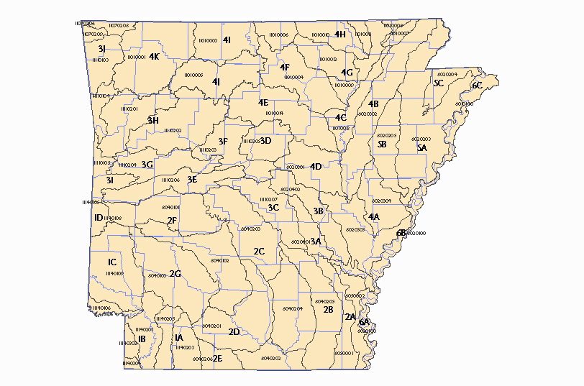
Ultimate Receiving Waters
- Red River
- Ouachita River
- Arkansas River
- White River
- St. Francis River
- Mississippi River

