**Responsiveness Summary to Comments Concerning Arkansas’s**

**Draft 2020 List of Impaired Waterbodies (303(d) List)**

The Arkansas Department of Energy and Environment, Division of Environmental Quality (Division or DEQ) appreciates all of those individuals and entities who submitted comments concerning the draft 2020 Impaired Waters List (303(d) list). Comments were received addressing other Division documents or issues, such as Assessment Methodology, Regulation No. 2, the 305(b) Report, or specific NPDES permits that were not open to public comment at time of this public notice. The Division encourages the authors to re-submit those comments when those documents or issues are opened for public review and comment.

Six comments were received from the individuals and/or entities, which appear alongside responses below:

**Comment 1) Arkansas Environmental Federation:**

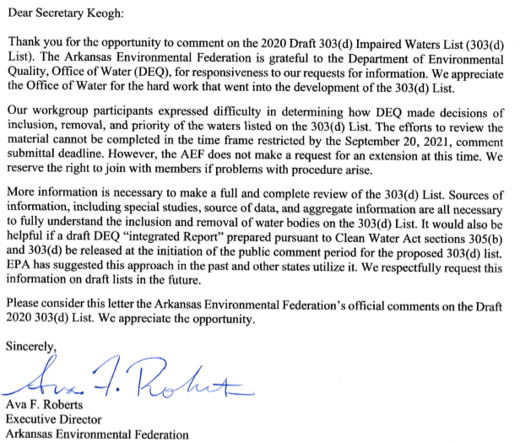

**Response 1)** The Division uses an Assessment Methodology, which is updated each assessment cycle, provided to data submitters, and posted on the DEQ website during the Call for Data. This methodology provides a detailed description of how data is reviewed and accepted according to quality control requirements as well as how each parameter is analyzed and assessed. The Division refers to this methodology throughout the assessment of all data received each assessment cycle.

According to 40 C.F.R. § 25.5(b) Notice, “A notice of each hearing shall be well publicized, and shall also be mailed to the appropriate portions of the list of interested and affected parties required by § 25.4(b)(5). Except as otherwise specifically provided elsewhere in this chapter, these actions must occur at least 45 days prior to the date of the hearing.” The Division’s public notice for the draft 2020 303(d) public comment period, which was published on August 1, 2021, to be ended on September 20, 2021, provided stakeholders with 50 days to review and comment on the list.

There are no statutory or regulatory requirements to public notice the 305(b) Report. Additionally, the draft 2020 305(b) report was not public noticed with the draft 303(d) list because of its incomplete nature. Several sections of the draft 2020 305(b) report are not completed until the 303(d) list is complete.

**Comment 2) FTN Associates Ltd.:** 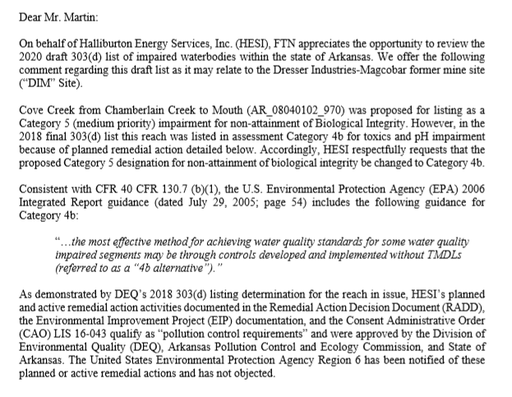

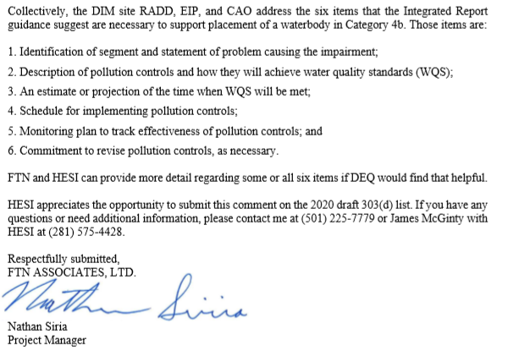

**Response 2)** The Division agrees, the biological integrity listing for AR_08040102_970 will be revised to Category 4b.

**Comment 3) El Dorado Chemical Company:**

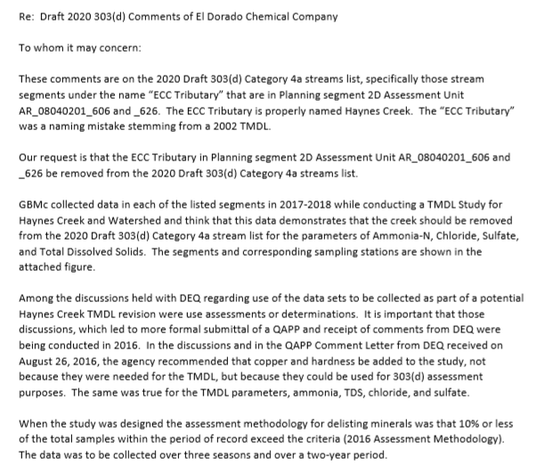

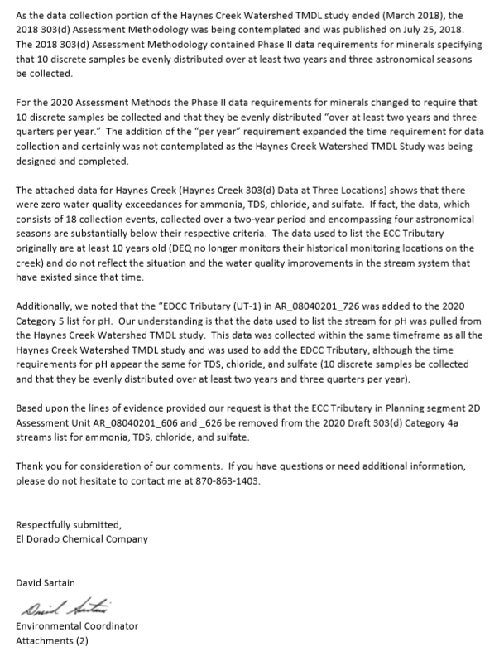

**Response 3)** The Division agrees that AR_08040201_606 should be named Haynes Creek and will revise in the final list.

Samples considered characteristic of the main water body that were received for the 2020 assessment cycle spanned just over 1 year (Feb. 2017 – March 2018), which does not fulfill the following requirements in the assessment methodology: “Discrete data must be evenly distributed over at least two (2) years and three (3) quarters per year.” Although AR_08040201_726 did not meet the 2-year requirement, the Division decided to list it for pH based on the fact that, within that limited amount of time, there was a 66% (8/12) exceedance rate of available data. As detailed in section 3.10 of the 2020 Assessment Methodology, “Attainment decisions will be based on the most appropriate and protective decision for the [assessment unit]…. A weight of evidence approach will be used to make the final attainment decision.” These final attainment decisions that deviate from the Assessment Methodology will be justified in the 2020 305(b) Integrated Report.

While looking into the request to remove pH based on minimum data requirements, it was determined that the copper listing on AR_08040201_606 did not meet the same temporal requirements laid out in the assessment methodology and could not be de-listed.

**Comment 4) Arkansas Department of Transportation**

To whom it may concern:

The Arkansas Department of Transportation requests that the Department of Energy and Environment Division of Environmental Quality provide the 303(d) list in a more user friendly format. Previous lists have been organized by Planning Segment which places impaired streams together that share the same regional characteristics. The 2020 draft lists streams alphabetically by name.  This arbitrary method of categorization creates confusion when multiple waterbodies have the same name (e.g. Big Creek, Bear Creek, Caney Creek) and also lacks alphabetical convention in the example of Bayou De L’outre which has several listings and then is followed by Bayou Des Arc, Bayou DeView, and Bayou Imbeau before additional listings for Bayou De L’oture.

The lack of geographical based listing in conjunction with the new format makes it more difficult to determine new listings and de-listings.

Previous years included documents outlining new listings and de-listings as well as a variety of maps. We request a planning segment based list of the 2020 impaired waterbodies.

Sincerely,

Lindsay Zweifel

Advanced Water Quality Specialist

ARDOT-Environmental Division

**Response 4)** The Division agrees with the request to provide the list in the order of Planning Segment and Assessment Unit and will revise as needed in the Final List. For geographical representations of the 2020 draft listings, the Division refers commenters to AquaView, which is linked as “Draft 303d List – Online Maps” on the webpage referenced in the public comment letter (https://www.adeq.state.ar.us/water/planning/integrated/303d/list.aspx).

**Comment 5) Beaver Water District:**

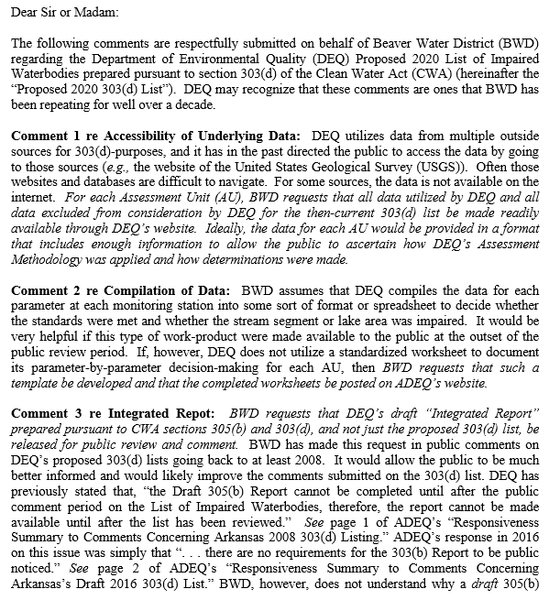

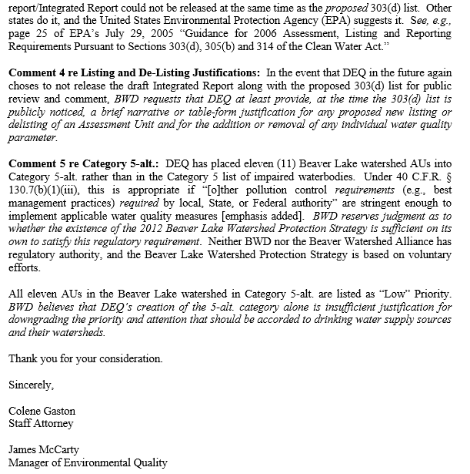

**Response 5)** Accessibility of Underlying Data: The Division recognizes the difficulty of navigating outside data provider websites, and the Division is committed to continuing to work toward making data and assessments readily available via web-based interface as resources allow.

Compilation of Data: The Division is committed to continuing to work toward making data and assessments readily available via web-based interface as resources allow.

Integrated Report: There are no statutory or regulatory requirements to public notice the 305(b) Report. Additionally, the draft 2020 305(b) report was not public noticed with the draft 303(d) list because of its incomplete nature. Several sections of the draft 2020 305(b) report are not completed until the 303(d) list is complete.

Listing and De-Listing Justification: The Division acknowledges the comment.

Category 5-alt: The Division placed four assessment units (AUs) in category 5 alt for *E. coli* and turbidity impairments in the Beaver Lake watershed. After reviewing the data for this response, it was determined that AR_11010001_4042 should be de-listed for turbidity as it attains for base flows and storm flows and de-listed for *E. coli* as it attains for primary and secondary contact recreation. The Beaver Lake Watershed Protection Strategy is working as evidenced by one of the three Beaver Lake AUs being de-listed in this assessment for turbidity. AR_11010001_4040 did not have enough data to be delisted for storm flows and did have exceedances. Additionally, the dataset is lacking in recent data, with only 3 samples taken in the last 2 years of the period of record; the exceedances occurred just before this decrease in data collection. AR_11010001_4041 had no exceedances of the data, but it was not de-listed because the data did not meet the minimum sample requirements. The Division recommends more sampling on these segments before making the decision to de-list. The low priority is only a reflection of a strategy already in place that is showing improvement in multiple AUs.

**Comment 6) Arkansas Department of Energy and the Environment**

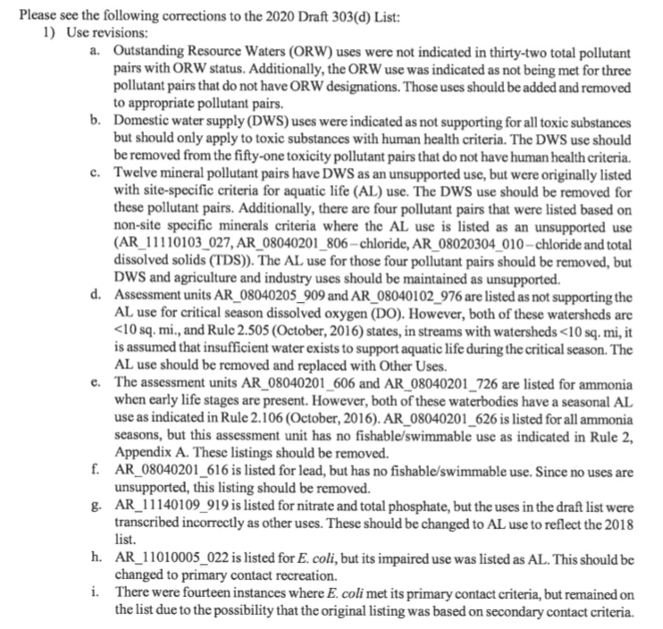

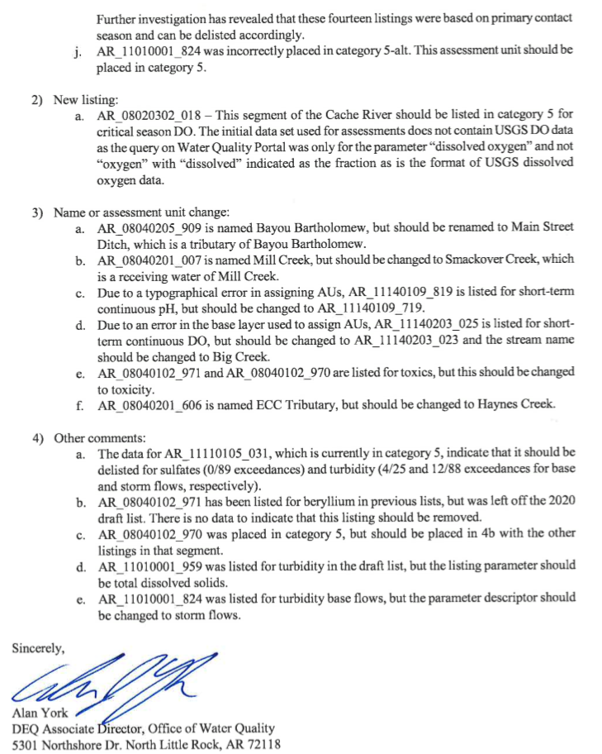

**Response 6)** The Division agrees with all other comments and will make applicable revisions including the following:

1. Nine additional assessment units were identified as needing an ORW designated use.
2. Town Branch (AR_11010001_959) was listed for Turbidity base flows, but should have been listed for total dissolved solids.
3. The assessment unit AR_11010010_012 had been called AR_11010010 _912 in the draft list.
4. Three assessment units that were placed in planning segment 4E should have been in 1A.
5. The following assessment units were also removed from the draft list due to a transfer error from the 2018 list:

|  |  |
| --- | --- |
| AR_08040203_913 | Turbidity |
| AR_11140109_014 | Dissolved Oxygen |
| AR_11110206_4052 | Dissolved Oxygen |
| AR_08040101_048 | Turbidity |